

**Earendel** Pro-Track**:**

**IoT-Enabled Celestial Tracker**

**Project Proposal**

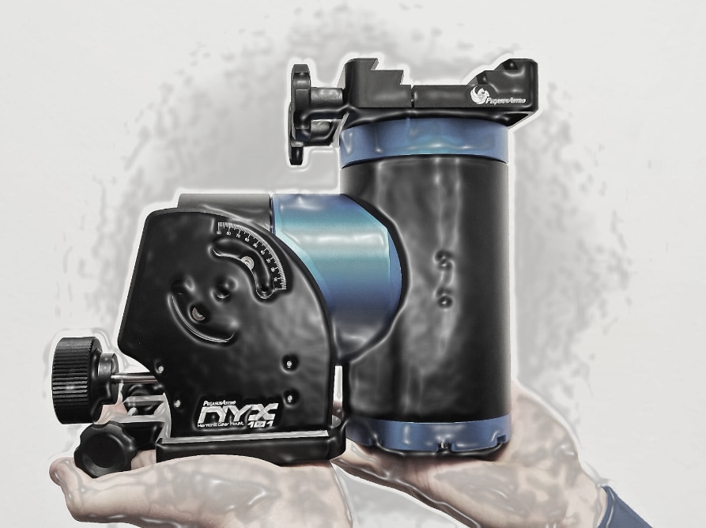

|  |  |
| --- | --- |
| **Team Name** | **Vanguard Silicon** |
| **Category** | University |
| **Theme** | **INDUSTRY 4.0** |

# Problem Definition

## Introduction

**Observations:** Regular stargazing sessions revealed the challenge of manually tracking celestial objects due the position of the celestial bodies differ with location/altitude and to their constant motion across the sky.

Identified Problem: The need for an automated, user-friendly telescope mount capable of accurately tracking celestial bodies to enhance stargazing experiences and simplify astronomical observations for enthusiasts and beginners.

## Problem Analysis

The identified problem of manual tracking of celestial bodies has significant relevance and impact across various sectors:

1. **Astronomy and Science Education:** Simplifying celestial tracking enhances learning experiences for students and enthusiasts, gaining a deeper understanding of astronomy.
2. **Research and Discovery:** Accurate tracking aids researchers in prolonged observations, critical for studying celestial phenomena, from variable stars to deep-space objects.
3. **Tourism and Entertainment:** Improved stargazing experiences attract tourists to observatories and dark-sky destinations, promoting astronomy-based tourism.

IoT can address specific aspects of this problem by:

1. **Automating Positioning:** IoT sensors can continuously track celestial positions and adjust the telescope mount's orientation in real time, eliminating the need for manual adjustments.
2. **Remote Control and Monitoring:** IoT-enabled systems allow users to control telescopes remotely via mobile apps, expanding accessibility for educational or research purposes.

The identified problem aligns with Industry 4.0 principles by integrating IoT, AI, and automation:

1. **IoT Integration:** IoT devices gather data on celestial positions from online databases, facilitating seamless connectivity between the telescope mount and the app.
2. **Automation for Efficiency:** Automated adjustments based on real-time data reduce human intervention, aligning with the efficiency goals of Industry 4.0.

The potential integration of IoT, AI, and automation transforms the problem by:

1. **Enhancing Accuracy:** Real-time data ensures precise tracking, improving observation quality.
2. **Increasing Accessibility:** Remote control via IoT-connected apps democratizes access to astronomy, benefiting education and public engagement.
3. **Enabling Continuous Operation:** Automated adjustments allow telescopes to operate for extended periods, facilitating long-term observations for research purposes.

# Proposed Solution

## Proposed Product

The proposed solution is an Equatorial mount for telescope with IoT integration and an accompanying mobile app:

Key Features:

1. **IoT Connectivity:** Links to online celestial databases for real-time celestial body positions.
2. **Automated Tracking:** Constantly adjusts telescope orientation for precise celestial tracking.
3. **Mobile App Control:** Allows remote operation and monitoring via user-friendly interface.
4. **AI Predictive Algorithms:** Enhances accuracy by predicting celestial movements for proactive adjustments.

Industry 4.0 Integration:

* **IoT Connectivity:** Accesses and synchronizes data from online databases for seamless tracking.
* **AI Integration:** Utilizes predictive algorithms for precision and preemptive adjustments.
* **Remote Control:** Enables users to operate telescopes remotely, aligning with automation principles.

## Uniqueness of the Solution

Our solution innovates on existing telescope mounts by:

1. **Real-time IoT Connectivity:** Uniquely accesses live celestial databases for instantaneous tracking updates.
2. **Seamless Mobile Control:** Enables intuitive remote operation through a user-centric mobile app interface.
3. **Continuous Observation:** Ensures uninterrupted tracking, distinguishing it from manual or intermittent tracking systems.
4. **Educational Focus:** Designed for ease of use, enhancing learning experiences for beginners and enthusiasts.

These aspects uniquely address the problem by providing unparalleled accuracy, real-time adjustments, and user-friendly accessibility, significantly enhancing stargazing experiences.

# Technical Overview and Implementation

## Technical Details

Implementation Overview:

1. **Hardware Integration:** Develop an Equatorial mount with IoT sensors for data collection.
2. **Database Connectivity:** Establish links to online celestial databases for live position updates.
3. **Mathematical Models:** Develop intricate mathematical algorithms to calculate and forecast celestial movements based on established astronomical principles and equations.
4. **Mobile App Development:** Create a user-friendly interface for remote control and monitoring.
5. **Testing and Refinement:** Conduct rigorous testing to ensure seamless integration and accuracy.
6. **User Training and Support:** Provide resources and support for users to maximize the solution's potential.

# User Scenario

1. **Evening Observation Session:** A user sets up the Equatorial mount telescope in their backyard.
2. **App Initialization:** They launch the mobile app, connecting it to the telescope via IoT.
3. **Select Celestial Object:** Using the app, they select a specific star or planet of interest.
4. **Real-time Tracking:** The telescope adjusts automatically, continuously tracking the chosen celestial body.
5. **Smooth Observation:** Without manual intervention, the user enjoys uninterrupted, precise observation, enhancing their stargazing experience.
6. **Educational Value:** Beginners learn effortlessly while enthusiasts delve deeper into celestial wonders.

# Team Details

Please provide necessary details of your team. All fields, including photographs, are required

Team Leader

Full Name: Yasiru Nipun Basnayake

Email: yasirunipunbasnayake@gmail.com

Mobile Number: 070 253 4485

Team Member

Full Name: Kavindu Jayathissa

Email: kavindujayathissa0@gmail.com

Mobile Number: 076 130 1200

Team Member

Full Name: Linuka Ratnayake

Email: linukahr@gmail.com

Mobile Number: 070 181 5730

Team Member

Full Name: Kumuthu Novinya De Zoysa

Email: knovinya@gmail.com

Mobile Number: 071 939 7910

Team Member

Full Name: Aruna Priyabhashana Ehelepola

Email: aruna25ehelepola@gmail.com

Mobile Number: 071 298 7321

# Additional Information

*Include any additional information or attachments that support your proposal. Please ensure that the content provided does not exceed this page.*

* *Visual Design of the telescope mount type our team chose*

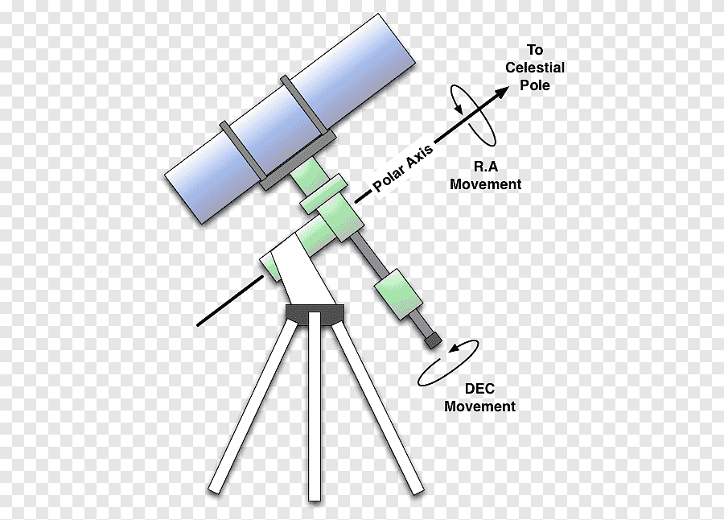

* *For now, the team has discussed that the method of movement for the actuators will be Stepper motors. These motors are free from noisy/glitchy vibrations and provide accurate/precise movements compared to generic servo motors.*
* *Sensor data pertaining to the telescope's orientation decision will be processed through precise gyroscope/magnetometer sensors for orientation data and a GPS sensor for location data. For the movements of the actuators, the discussion leans towards employing PID algorithms to ensure secure and stable movements of the mount actuators. Our priority lies in prioritizing* ***security over speed*** *to safeguard the telescope device.*
* *The tracking system is planned to be simulated using real-time data fetched from the celestial body placement database. If time allows, we aim to implement an AI-based prediction algorithm to smoothly track the selected celestial body, avoiding direct reliance on discrete data from the database. The database data will be utilized for verification purposes.*
* *The mechanism for tracking celestial objects involves first orienting the telescope parallel to Earth’s North or South celestial pole. Subsequently, the telescope is rotated along the* ***Right Ascension Axis*** *and* ***Declination Axis*** *to track celestial bodies, compensating for the Earth’s rotation effects.*